# **Predicting Success of Bank Direct Marketing By ISAS**

ID:773950464

NAME: Yong Wan

UPI: wany991

## Abstract

This paper focuses on how to improve the work efficiency of phoning marketing on a bank due to there is only 10% success now. There are two data files which recorded during different periods. So at beginning, we use Field Ops function to merge the data, such as "Type","Filter","Derive" and "append" etc.., before we start choosing model methods, we use functions included"Reclassify","Partition","Derive","Feature Selection" , "Filter", "Distribution", "Balance Node(Reduce)" to organize the source data. Then we compared seven model method and got the result by combining five model methods. The result is amazing it only lost 0.59% target clients but can reduce 46% phones so that the work efficiency will be double than before.

## 1.Business and Situation understanding.

“First is developing an understanding of the application domain and the relevant prior knowledge and identifying the goal of the KDD process from the customer’s viewpoint.” (Fayyad et al., 1996)

### 1.1 Identify the objectives of the business and situation

Marketing sales activities are a typical promotion strategy business. For a bank, it is not an exception. Banks use direct marketing when targeting segments Customers connect with them to achieve specific goals. But how to improve the success of these kinds of marketing activities is a big problem for bank managers. This paper aims to improve it by analysis the data which a bank collected from May 2008 to November 2010 through methods of data mining and KDD.

### 1.2 Assess the situation

### Base on the data, there were only 10% of success in the past three years, it means there is a massive gap between success and unsuccess. Also, we should do something to improve it to decrease the phone call times due to our customers may be annoyed and increase the profit for banks due to the phone agents get more success by same phone outs as before. So we aim to decrease 40% of the total amount of phoning out and at max decrease 5% of the total of successful calls. This means we will get at least 20% of success of phoning ,double than before. Also, it means we should get at least 90% correct prediction on customers who's original answer is Yes and nearly 40% accurate prediction on the customers who's original answer is No.

### 1.3 Determine data mining objectives

This objective is to predict the success of phoning a customer then decided whether he was worth to call.

Task list

1.Describe the methods for model assessment (for example, accuracy, performance, etc.).

2.Define benchmarks for evaluating success. Provide specific numbers.

3.Define subjective measurements as best you can and determine the arbiter of success.

4.Consider whether the successful deployment of model results is part of data mining success. Start planning now for deployment.

### 1.4 Produce a project plan

|  |  |  |  |
| --- | --- | --- | --- |
| Phase | Time | Resources | Risk |
| Business understanding | 0.5 week | All analysts | Economic Crisis |
| Data understanding | 2 weeks | All analysts | Economic Crisis |
| Data preparation | 4 weeks | All analysts | Economic Crisis |
| Modeling | 3.5 weeks | All analysts | Economic Crisis |
| Evaluation | 1 week | All analysts | Economic Crisis |
| Deployment | 1 week | All analysts | Economic Crisis |

## 2. Data understanding.

Data provides the “raw materials” of data mining. This phase addresses the need to understand what your data resources are and the characteristics of those resources. “Second is creating a target data set: selecting a data set, or focusing on a subset of variables or data samples, on which discovery is to be performed.” (Fayyad et al., 1996)

### 2.1 Collect initial data

Link https://archive.ics.uci.edu/ml/datasets/bank+marketing

Citation Request:

This dataset is publicly available for research. The details are described in [Moro et al., 2014].

Please include this citation if you plan to use this database:

[Moro et al., 2014] S. Moro, P. Cortez and P. Rita. A Data-Driven Approach to Predict the Success of Bank Telemarketing. Decision Support Systems, Elsevier, 62:22-31, June 2014

Title:Bank Marketing Data Set

Source:

[Moro et al., 2014] S. Moro, P. Cortez and P. Rita. A Data-Driven Approach to Predict the Success of Bank Telemarketing. Decision Support Systems, Elsevier, 62:22-31, June 2014

Relevant Papers:

S. Moro, P. Cortez and P. Rita. A Data-Driven Approach to Predict the Success of Bank Telemarketing. Decision Support Systems, Elsevier, 62:22-31, June 2014

S. Moro, R. Laureano and P. Cortez. Using Data Mining for Bank Direct Marketing: An Application of the CRISP-DM Methodology. In P. Novais et al. (Eds.), Proceedings of the European Simulation and Modelling Conference - ESM'2011, pp. 117-121, Guimaraes, Portugal, October, 2011. EUROSIS. [bank.zip]

In the above references, two datasets were created.

1)bank-additional-full.csv with 41188 examples and 20 inputs, recorded between May 2008 and November 2010.

2)bank-full.csv has all examples with 17 inputs, is an older version dataset and with less inputs than 1).

### 2.2 Describe the data

1.Amout of data

45211 rows in bank_full.csv and 41188 rows in bank_additional_full.csv

2.Value types:

There are 21 fields as we can see in Figure1.

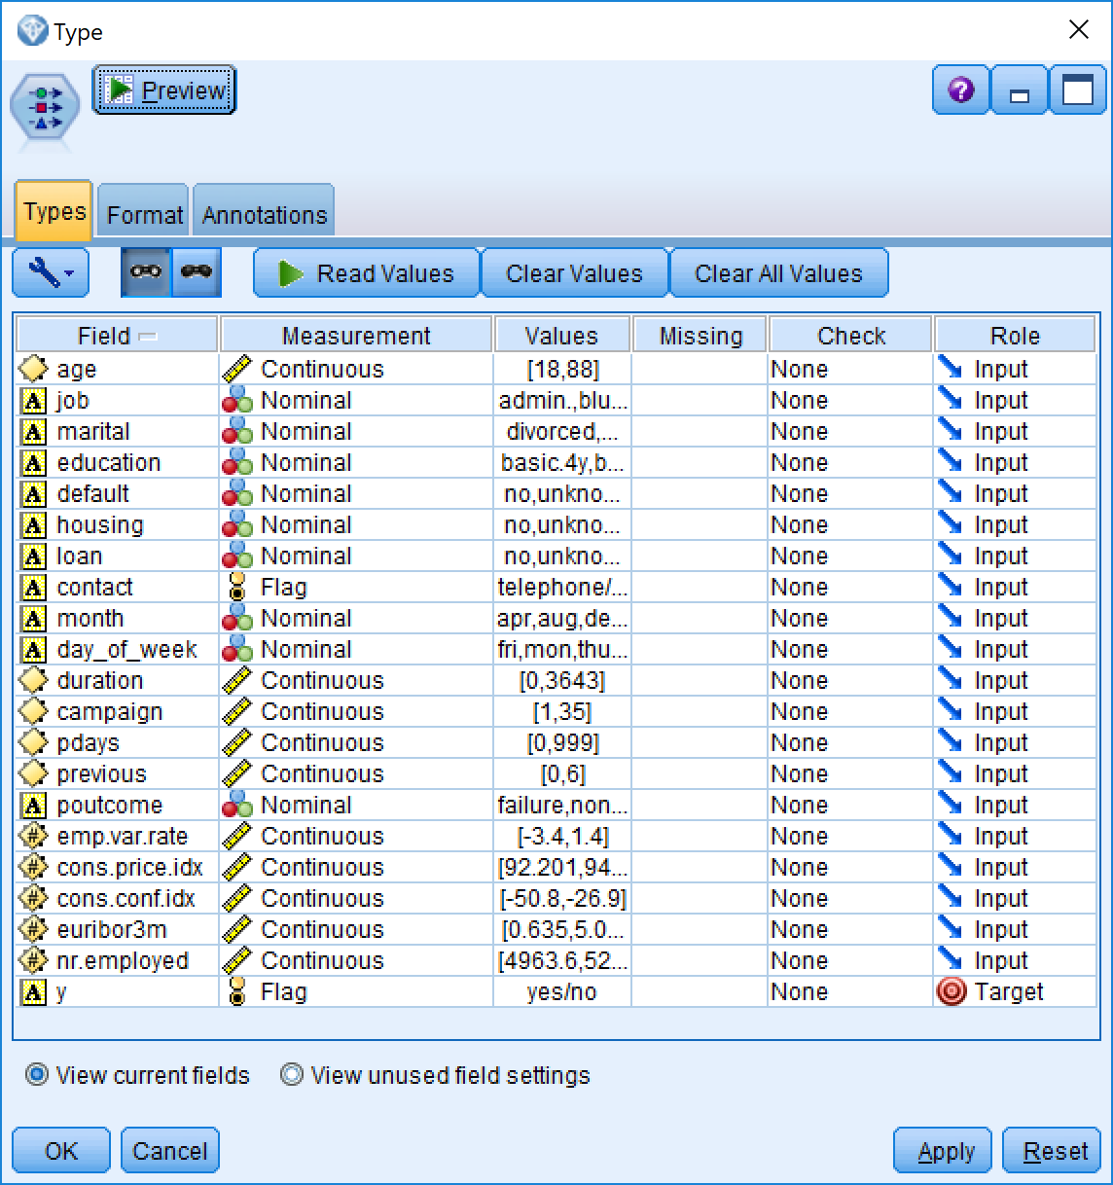

(Figure 1)

3.Coding schemes

1 - age (numeric in bank-additional-full.csv and string in bank-full.csv)

2 - job: type of job (categorical)

3 - marital: marital status (categorical)

4 - education (categorical)

5 - default: has credit in default? (categorical)

6 - housing: has housing loan? (categorical

7 - loan: has personal loan? (categorical)

# related with the last contact of the current campaign:

8 - contact: contact communication type (categorical)

9 - month: last contact month of year (categorical)

10 - day_of_week: last contact day of the week (categorical)

11 - duration: last contact duration, in seconds (numeric12 - campaign: number of contacts performed during this campaign and for this client (numeric, includes last contact)

13 - pdays: number of days that passed by after the client was last contacted from a previous campaign (numeric; 999 means client was not previously contacted)

14 - previous: number of contacts performed before this campaign and for this client (numeric)

15 - poutcome: outcome of the previous marketing campaign (categorical)

# social and economic context attributes

16 - emp.var.rate: employment variation rate - quarterly indicator (numeric)

17 - cons.price.idx: consumer price index - monthly indicator (numeric)

18 - cons.conf.idx: consumer confidence index - monthly indicator (numeric)

19 - euribor3m: euribor 3 month rate - daily indicator (numeric)

20 - nr.employed: number of employees - quarterly indicator (numeric)

4.Output variable (based on sensory data):

y - has the client subscribed a term deposit? (binary: 'yes','no')

### 2.3 Verify the data quality

Missing Attribute Values: bank-full.csv do not have emp.var.rate, cons.price.idx, cons.conf.idx , euribor3m, nr.employed. So after appending, these five fields should be null.

Five fields have data labelled unknown, for example: job ,marital,default,housing,loan.

## 3.Data preparation

“Third is data cleaning and pre-processing. Basic operations include removing noise if appropriate, collecting the necessary information to model or account for noise, deciding on strategies for handling missing data fields, and accounting for time-sequence information and known changes” (Fayyad et al., 1996)

### 3.1 Select the data

Due to we have more 80,000 rows of data, so we just simpled to discard the data which has unknown labels as showing in Figure 2.

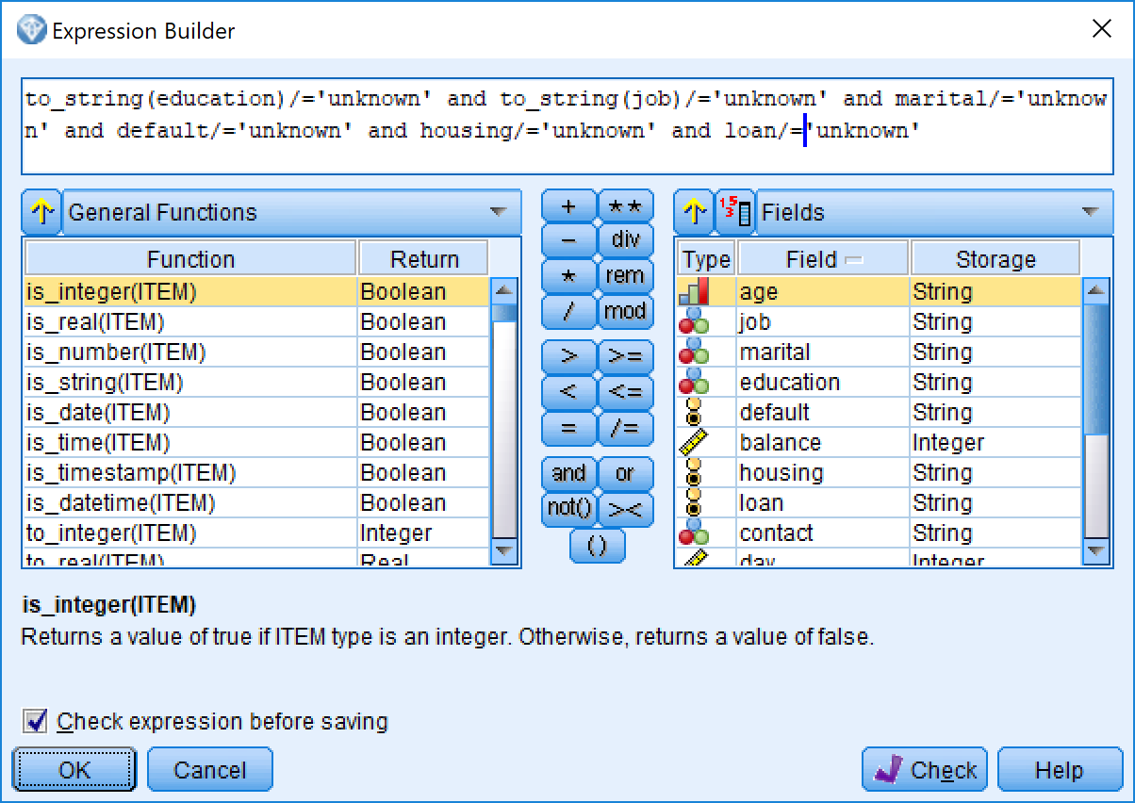

(Figure 2)

### 3.2 Clean the data

Because pdays<0 in bank-full.csv means the customer was not contacted before, but in bank-additional-full.csv, pdays=999 has same means, so we decide to change to same number 999 as the customer was not contacted before. It can be seen in Figure 3.

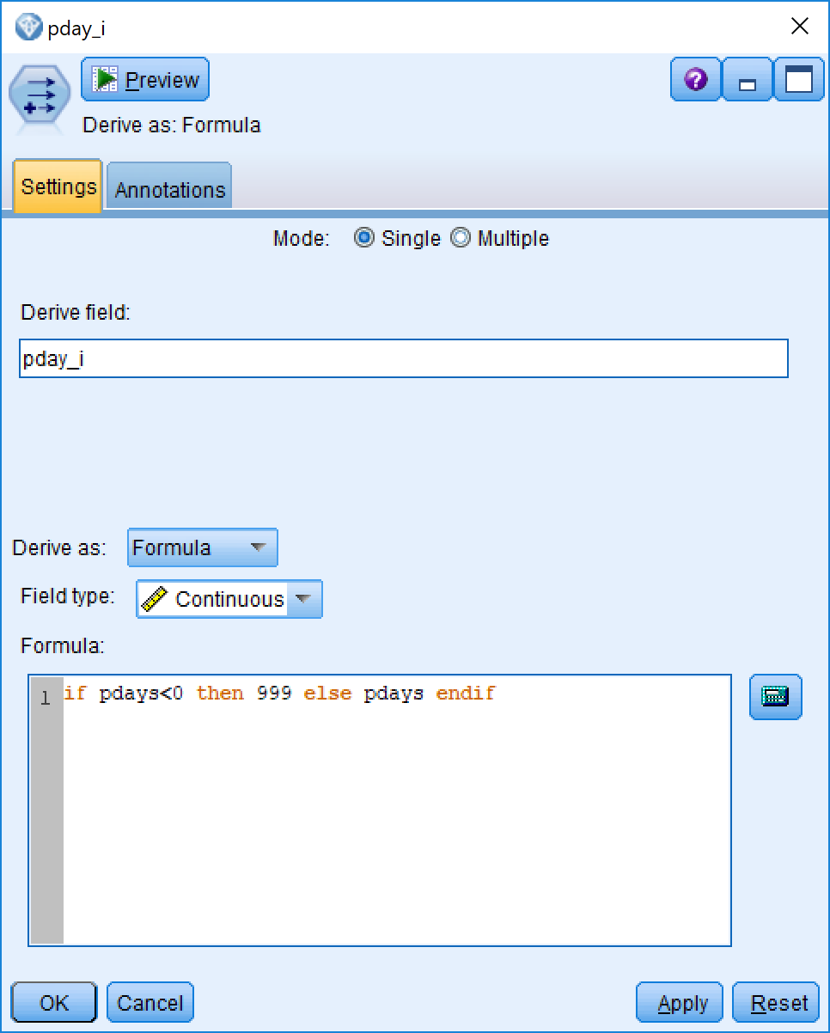

(Figure 3)

### 3.3 Construct the data

Due to there is not a primary key in original data, we decide to add a field named RecordID by function @Index as a primary key as showing in Figure 4..

It will be convenient to do merging operation.

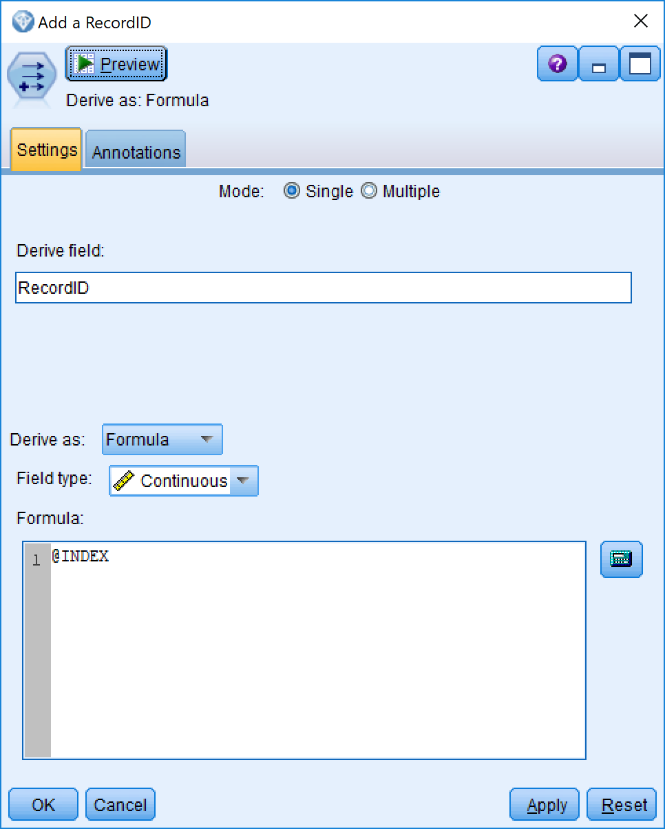

(Figure 4)

As we known age has different data types between bank-full.csv and bank-additional-full.csv.

it will not be able to append together. So we create a new field age_i which it equals to_integer(age) as we did in Figure 5.

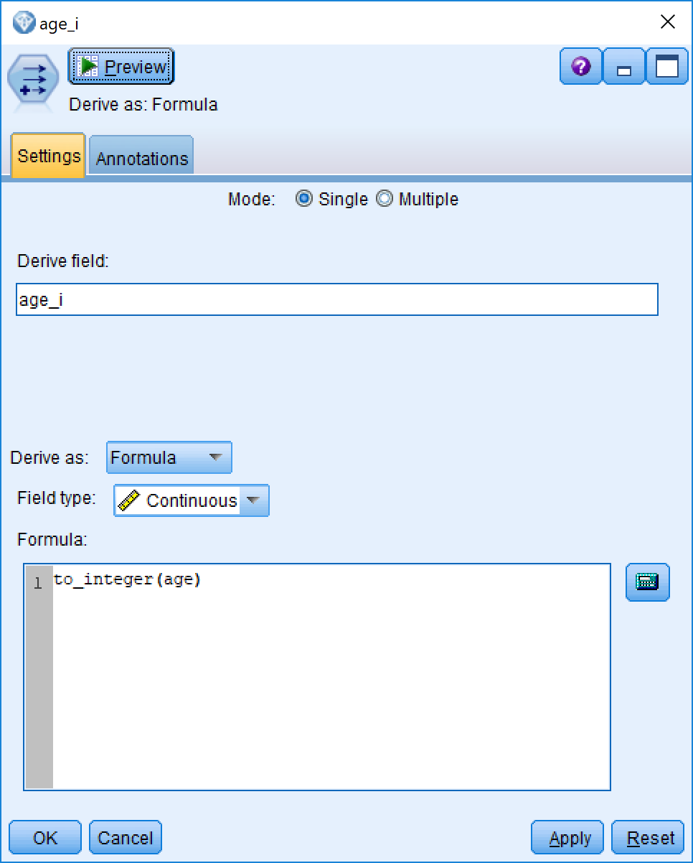

(Figure 5)

### 3.4 Integrate various data sources

From Figure 6,We know the education is different between the two datasets, we should reclassify this variable after appending to education_new.so we decided group “primary”, “basic.4y”,”basic.6y”,”illiterate” as primary, group “secondary”,”basic.9y”,”high.school” as “secondary”, then combine “tertiary”, ”professional.course”, ”university.degree” to “tertiary”

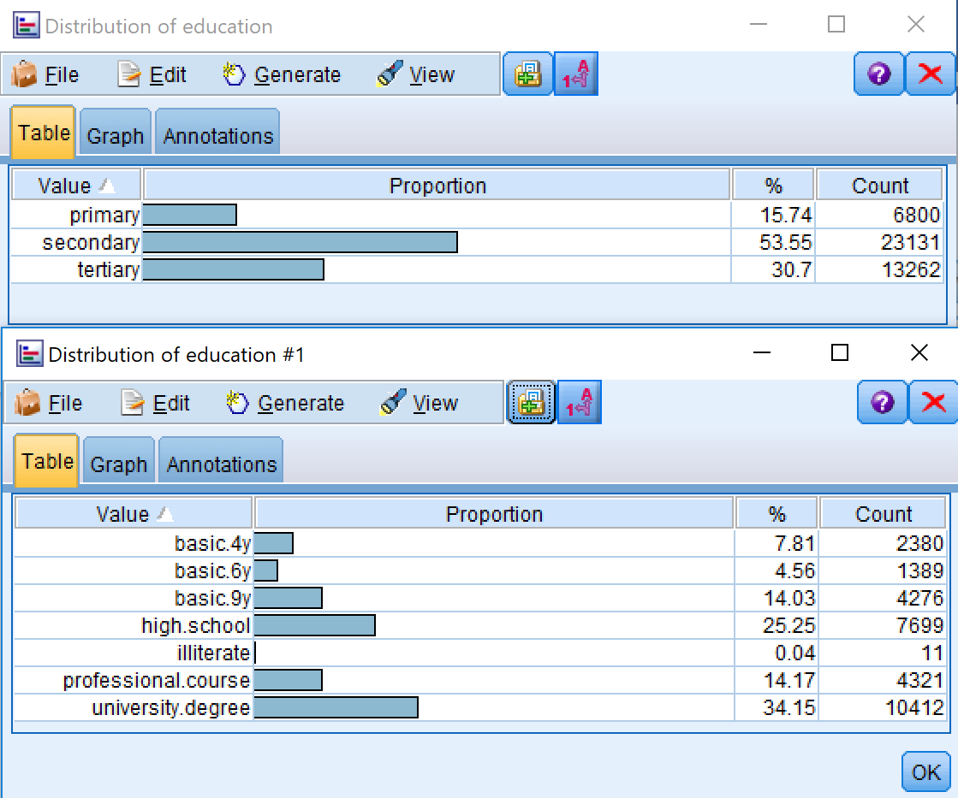

(Figure 6)

## 4.Data transformation

“Fourth is data reduction and projection: finding useful features to represent the data depending on the goal of the task. With dimensionality reduction or transformation methods, the effective number of variables under consideration can be reduced, or invariant representations for the data can be found.” (Fayyad et al., 1996)

### 4.1 Reduce the data

When we generate a distribution graph of y, we saw in Figure 7 that the data is

skewed (12% for Y and 88% for No). If a model did nothing, just sample say all of them are No for, it will be got 88% accuracy, I think it is useless for prediction. To fix this, we use ”Balance Node (Reduce)” to make the data approximately 50/50 as showing in Figure 8.

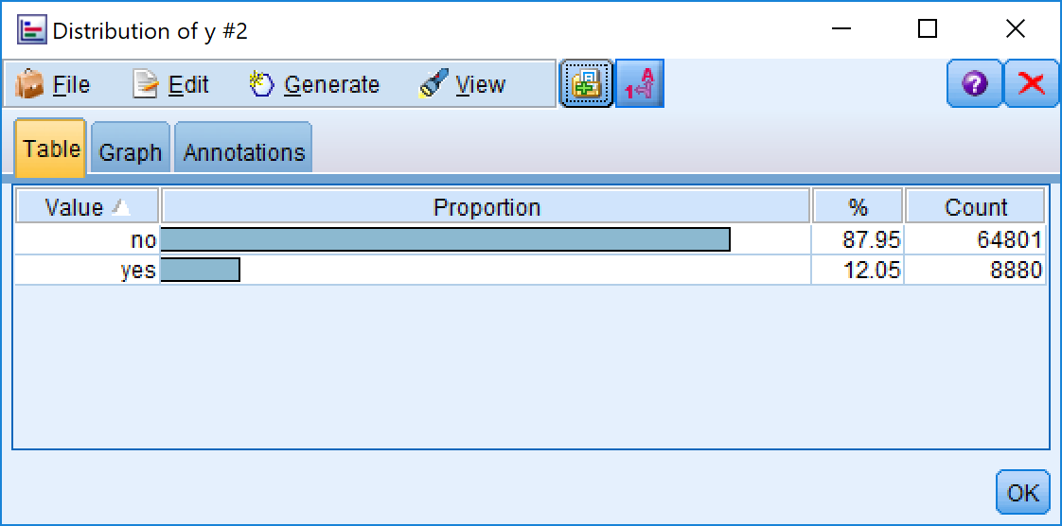

(Figure 7)

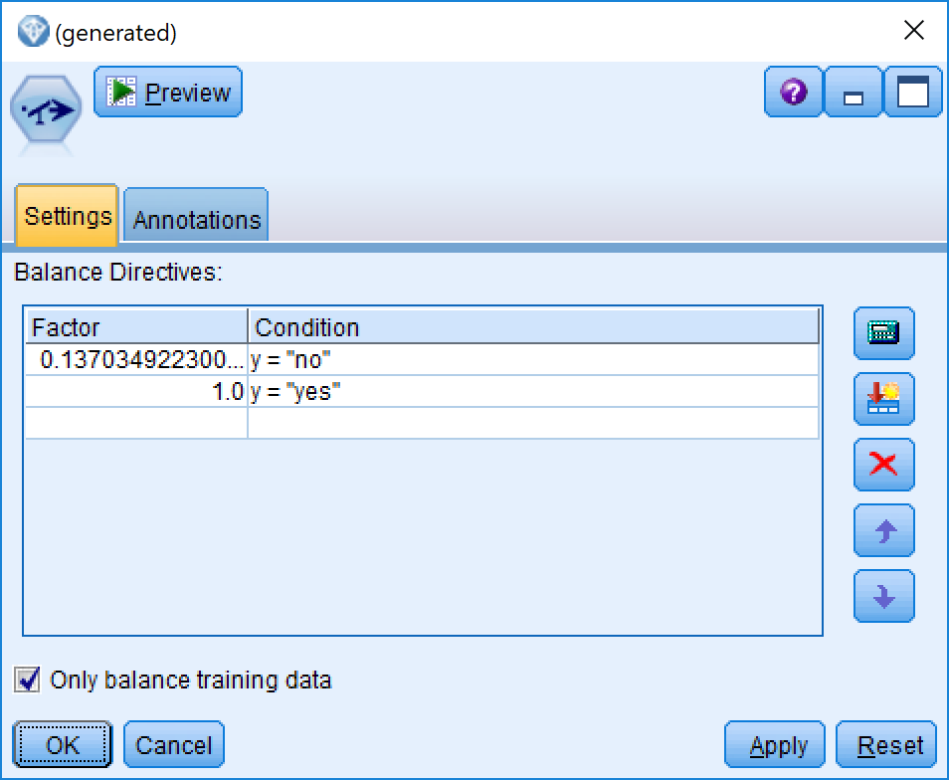

(Figure 8)

As there are too many null data on some fields, such as day_of_week, emp.var.rate, cons.price.idx, cons.conf.idx, euribor3m, nr.employed, we discard these six fields as we can see in Figure 9。

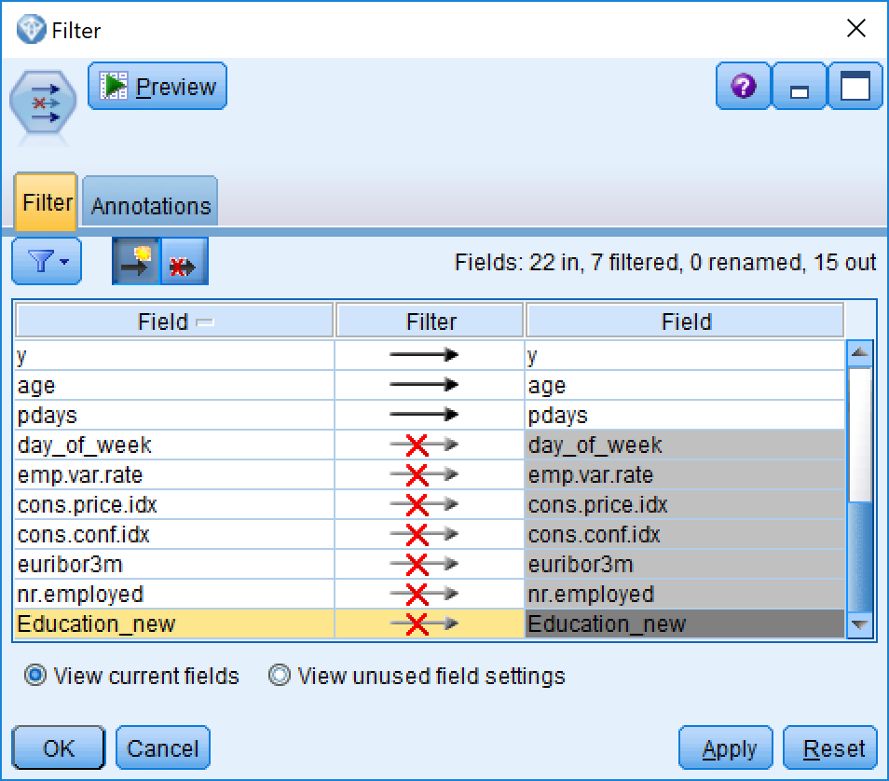

(Figure 9)

### 4.2 Project the data

Through “Feature Selection Model”, we decided to discard default field as it shows single category too large

For the duration, this attribute highly affects the output target (e.g., if duration=0 then y='no'). Yet, the duration is not known before a call is performed. Also, after the end of the call y is obviously known. Thus, this input should be discarded as we want to have a realistic predictive model.

In Figure 10, we use ”Partition” to random split the data to 80% for(training) ,10% to testing and 10% to validation.

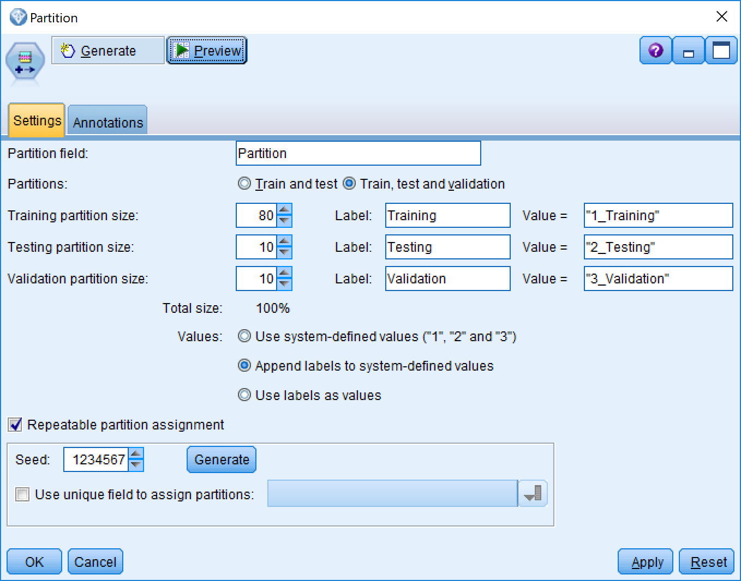

(Figure 10)

After that, we used “Auto Data Prep” to convert all of categorical or nominal field to continuous data in Figure 11. It will be benefit on model building.

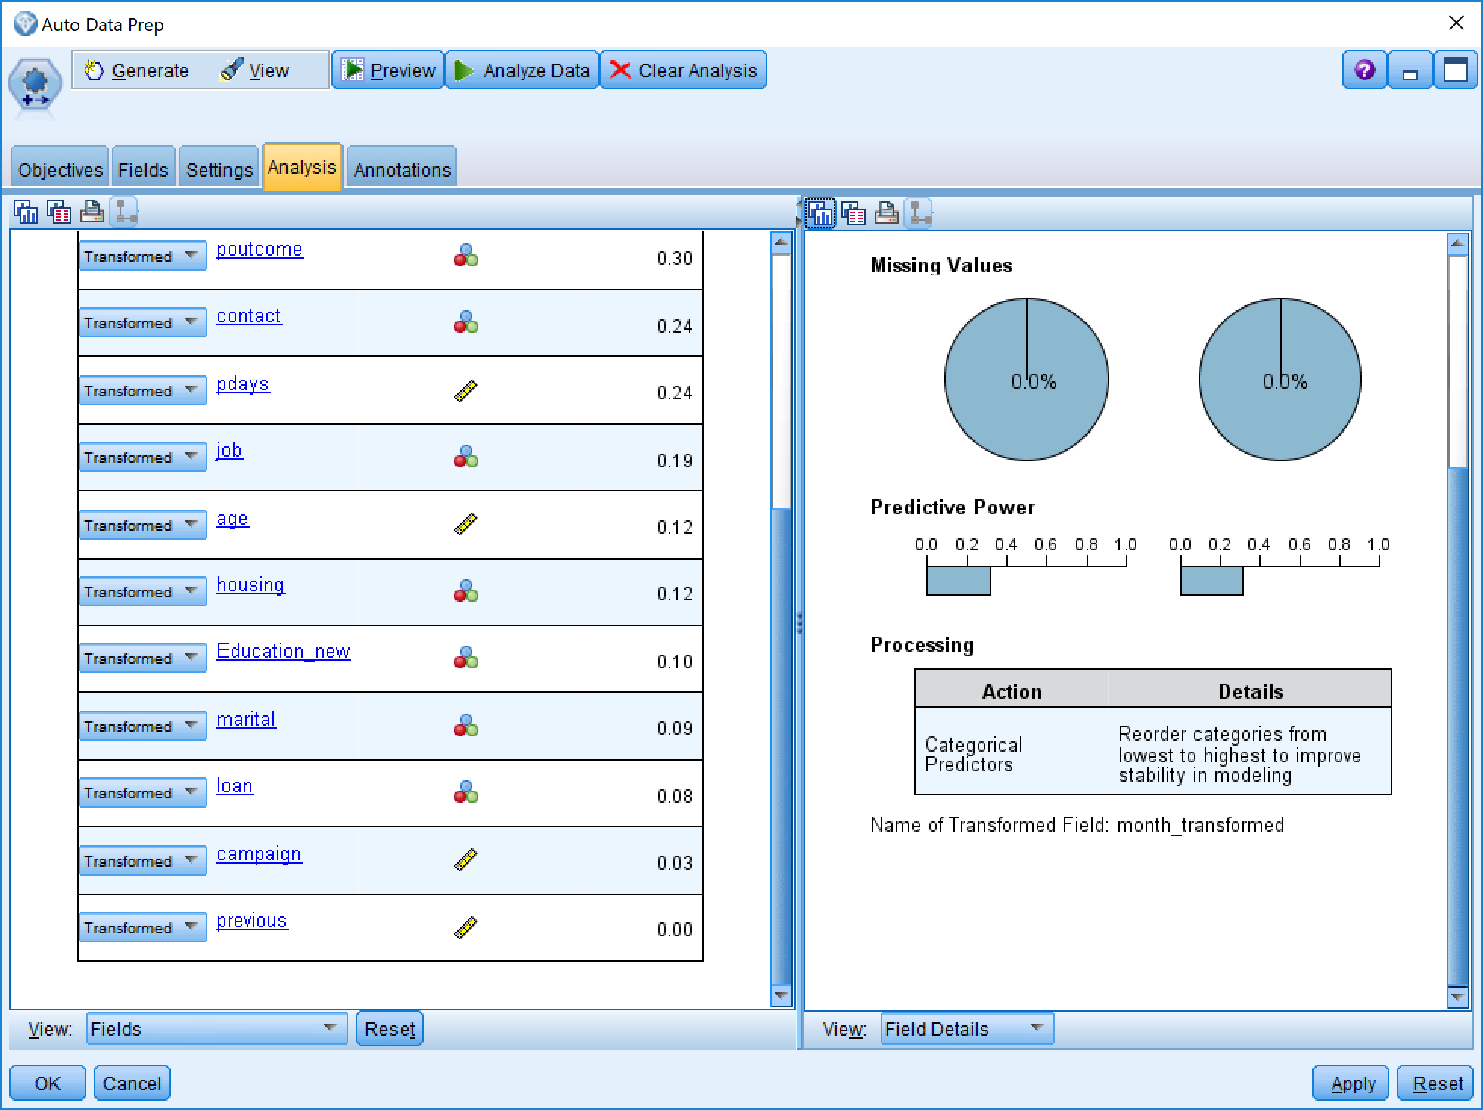

(Figure 11)

## 5.Data-mining method(s) selection

“Fifth is matching the goals of the KDD process (step 1) to a particular data-mining method. For example, summarization, classification, regression, clustering, and so on, are described later as well as in Fayyad, Piatetsky-Shapiro, and Smyth (1996).” (Fayyad et al., 1996)

the data mining methods we chose included

Python Model Group:Rondam Forest,Rondam Trees, Bayesian Network;

Decision Tree:C5.0 and C&R Tree

lassification and regression technique:Support Vector Machine (SVM),KNN

other mothods: XGBoost Tree,

### 5.1 Rondam Forest

From Figure 12, Age is the most important field for Random Forest Model, Campaign and Pdays are the second and third most important fields.

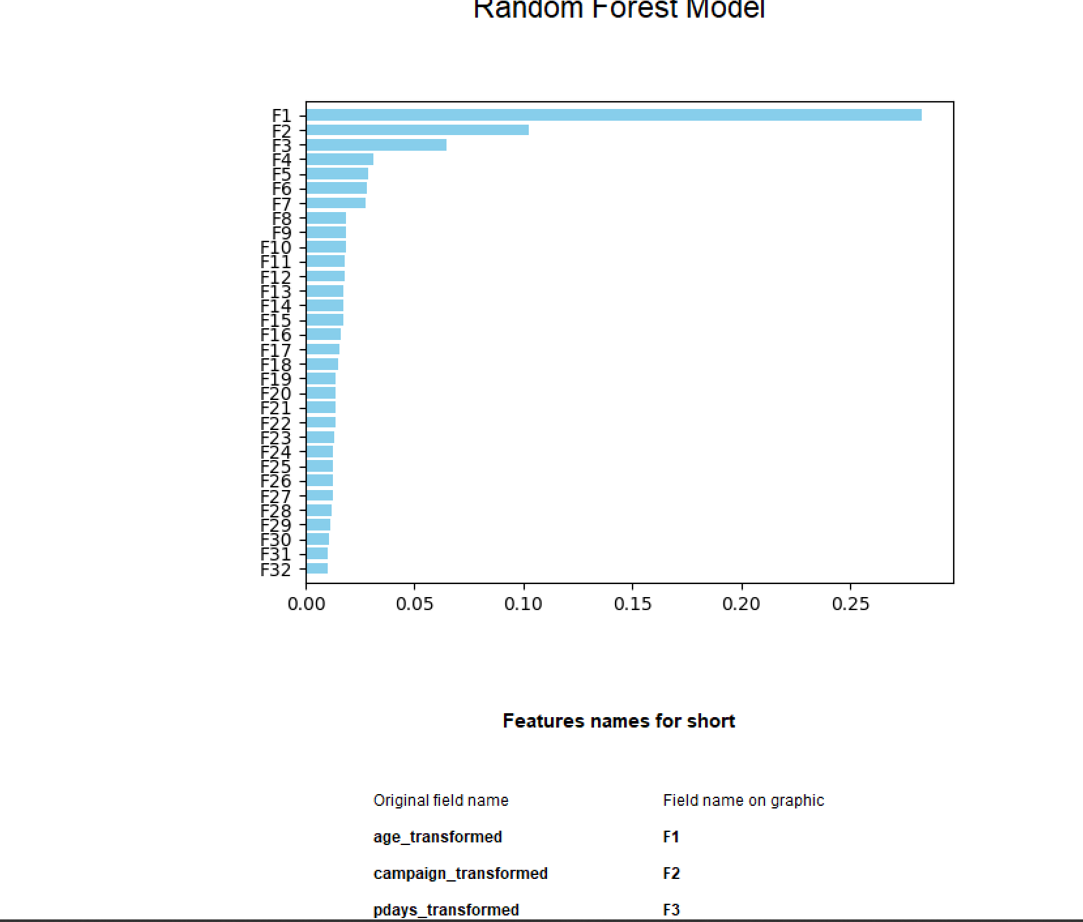

(Figure 12)

### 5.2 C5.0

From Figure 13, Month, housing, previous are the most important three factors for C5.0.

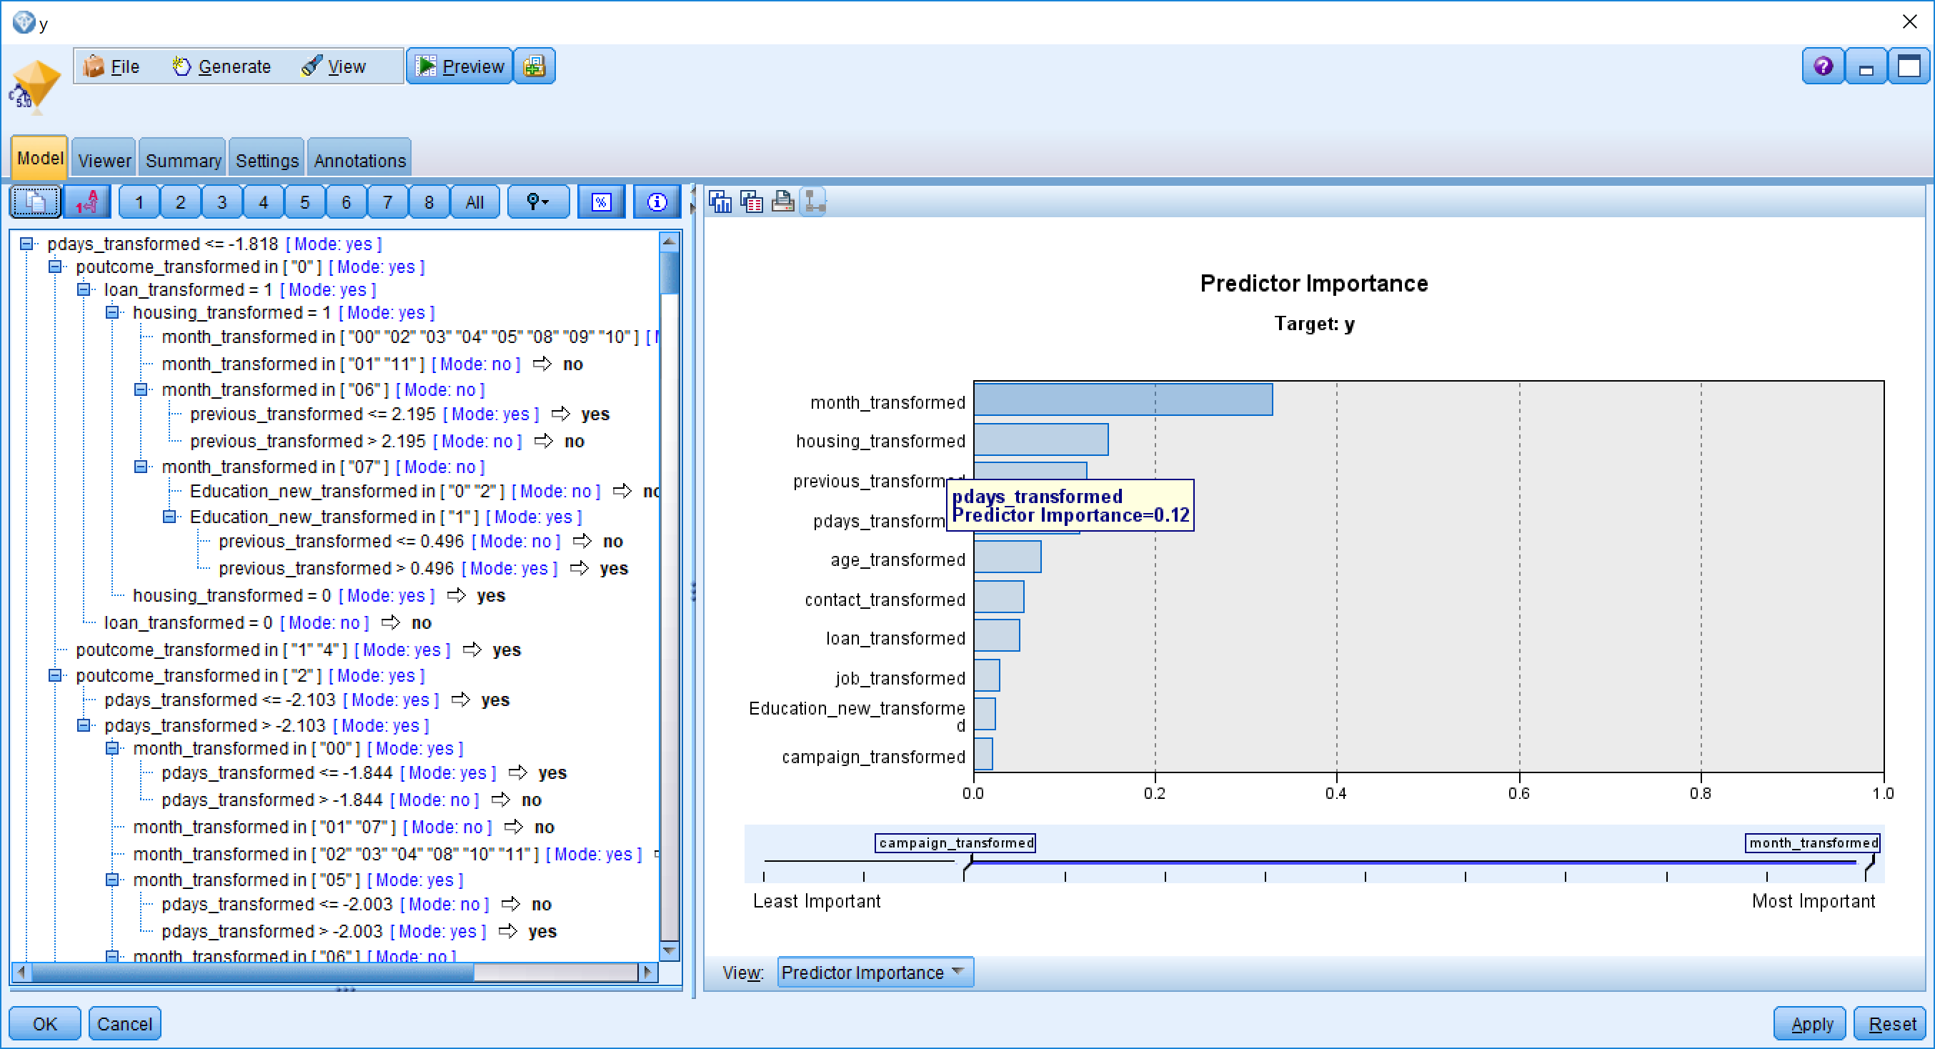

(Figure 13)

### 5.3 Random Trees

From Figure 14, in Random Trees, the most important factor is Job.

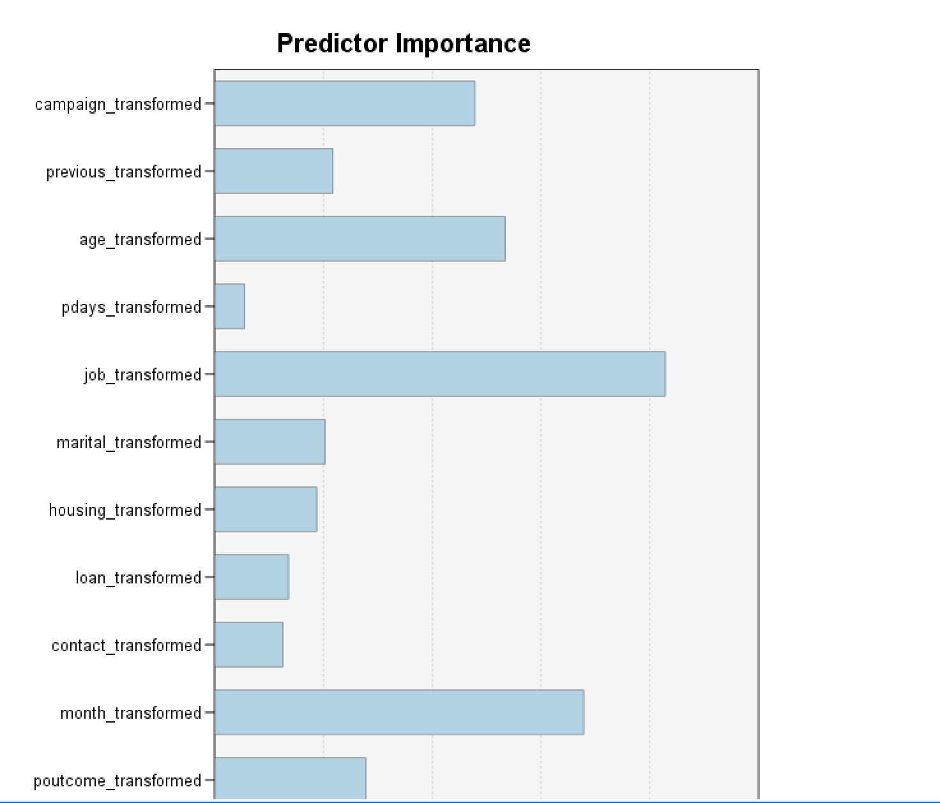

(Figure 14)

For the whole result, scores list in the Table 1- Eight modelling result comparing above:

|  |  |  |  |  |  |
| --- | --- | --- | --- | --- | --- |
| Order | Modeller Name | Total Training | Correct | Wrong | The Rate of Correct |
| 1 | KNN | 14293 | 10295 | 3998 | 72.03% |
| 2 | Random Tree | 14372 | 10235 | 4137 | 71.21% |
| 3 | C5.0 | 14235 | 10122 | 113 | 71.11% |
| 4 | Bayes Net | 14154 | 10003 | 4151 | 70.67% |
| 5 | Random Forest | 14418 | 10187 | 4231 | 70.65% |
| 6 | SVM | 14208 | 10006 | 4202 | 70.43% |
| 7 | CRT | 14238 | 9747 | 4491 | 68.46% |
| 8 | Neural Net | 14302 | 7516 | 6786 | 52.55% |

(Table 1-Eight modelling result comparing)

Select the appropriate data-mining method(s) based on discussion

Basing on Table 1- Eight modelling result comparing, obviously Neural Net got a very low result, it looks it totally did not match this task, so we decided to choose other seven methods including KNN,vand Random Tree,C5.0,Bayes Net, Random Forest and SVM , CRT to do the next step research.

## 6.Data-mining algorithm(s) selection

“Sixth is exploratory analysis and model and hypothesis selection: choosing the datamining algorithm(s) and selecting method(s) to be used for searching for data patterns. This process includes deciding which models and parameters might be appropriate (for example, models of categorical data are different than models of vectors over the reals) and matching a particular data-mining method with the overall criteria of the KDD process (for example, the end user might be more interested in understanding the model than its predictive capabilities).” (Fayyad et al., 1996)

For this task, as we know, there are only 10% of customers will be attracted

by marketing activities. So comparing to the correct rate of the whole data, the correct rate of customers who labelled success is more important. So we decide to look the different between these parts each modeling got.

We create a new field result_label in Figure 15, combined from the original exception field “Y” and the calculating exception field, which has labelled “No-No”,”No-Yes”,”Yes-Yes”,”Yes-No”,

“No-NO” means original is “NO”, and the calculation result also is “NO”

“Yes-Yes” means original is “Yes”, and the calculation result also is “Yes”

“No-Yes” means original is “NO”, and the calculation result is “Yes”

“Yes-No” means original is “Yes”, and the calculation result is “No”

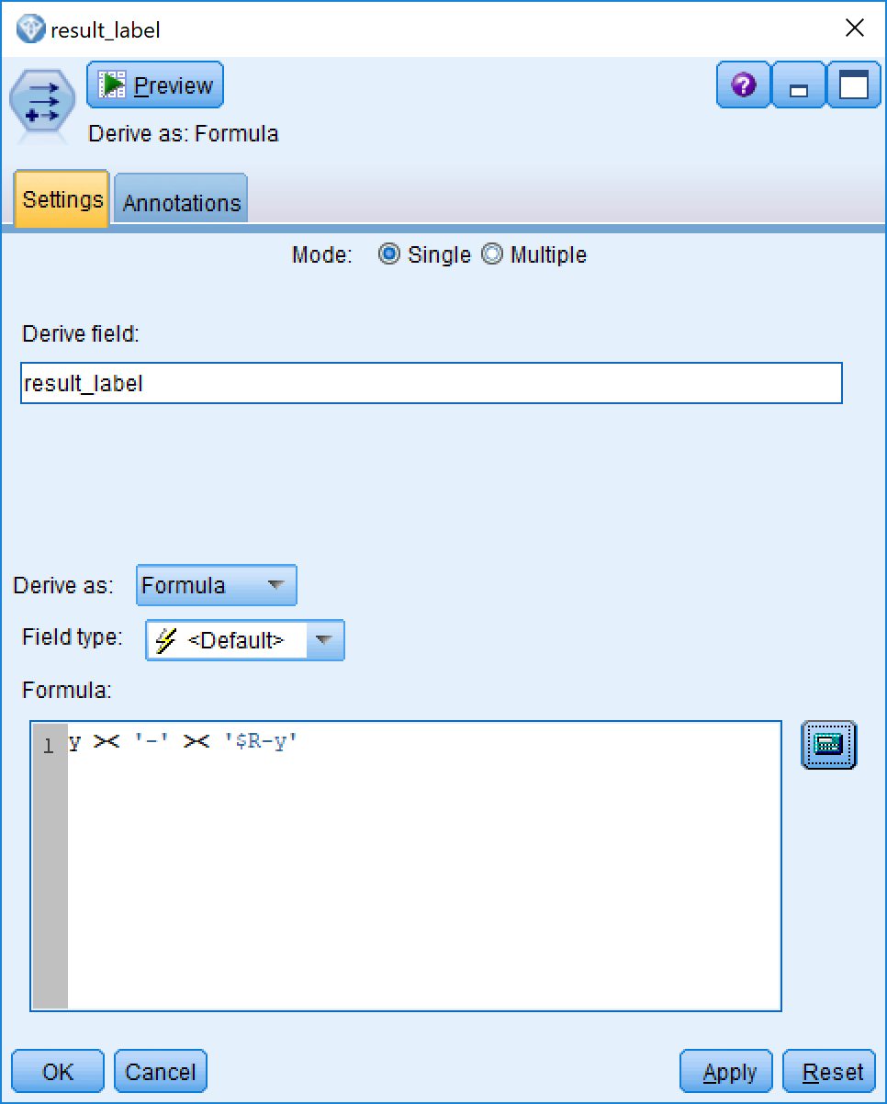

(Figure 15)

From Table-2 Yes-No comparing,KNN ,Random Forest and SVM got the best three score on “YES”, they only miss 14.38%,15.99% and 17.29% respectively. So we decided these three methods will be able to enter the next step.

|  |  |  |  |
| --- | --- | --- | --- |
| Order | Modeller Name | Number | The Rate of incorrect |
| 1 | KNN | 2541 | 14.38% |
| 2 | Random Forest | 2849 | 15.99% |
| 3 | SVM | 3085 | 17.29% |
| 4 | C5.0 | 3246 | 18.25% |
| 5 | Bayes Net | 3597 | 20.23% |
| 6 | Random Tree | 3958 | 22.36% |
| 7 | CRT | 4439 | 25.02% |

Table-2 Yes-No Comparing

From Table-3 No-Yes comparing, CRT, Random Forest and Bayes Net got the best three score on original “NO”, they only miss 5.56%,7.14% and 8.94% respectively. It means If we add these prediction data to the waiting phoning pool, it will not increase the number of failures. So we decided these three methods also will be able to enter the next step.

Table-3 No-Yes Comparing

|  |  |  |  |
| --- | --- | --- | --- |
| Order | Modeller Name | Number | The Rate of incorrect |
| 1 | CRT | 986 | 5.56% |
| 2 | Random Forest | 1263 | 7.14% |
| 3 | Bayes Net | 1590 | 8.94% |
| 4 | C5.0 | 1932 | 10.86% |
| 5 | SVM | 2205 | 12.36% |
| 6 | Random Tree | 2347 | 13.17 |
| 7 | KNN | 2437 | 13.69% |

So Totally, five Modeling are still in the pool we want to choose. They are KNN, Random Forest, SVM, CRT and Bayes Net. But there is also no any modelling which match the original target in the beginning of this report. Due to the accuracy on Yes is in 70%-80%,lower than our target, and the accuracy on No is also between 70-80%,higher than our target. So we could do something to improve the accuracy on Yes by decreasing the accuracy on No.

It is our final decision to combine the five models result, if any of these five models predict it is Yes, we predict it is “Yes”, in other words, if all of these models predict a customer will answer NO, we set it is No, otherwise it will be Yes.

Let us have a look at the final data in Figure 16.

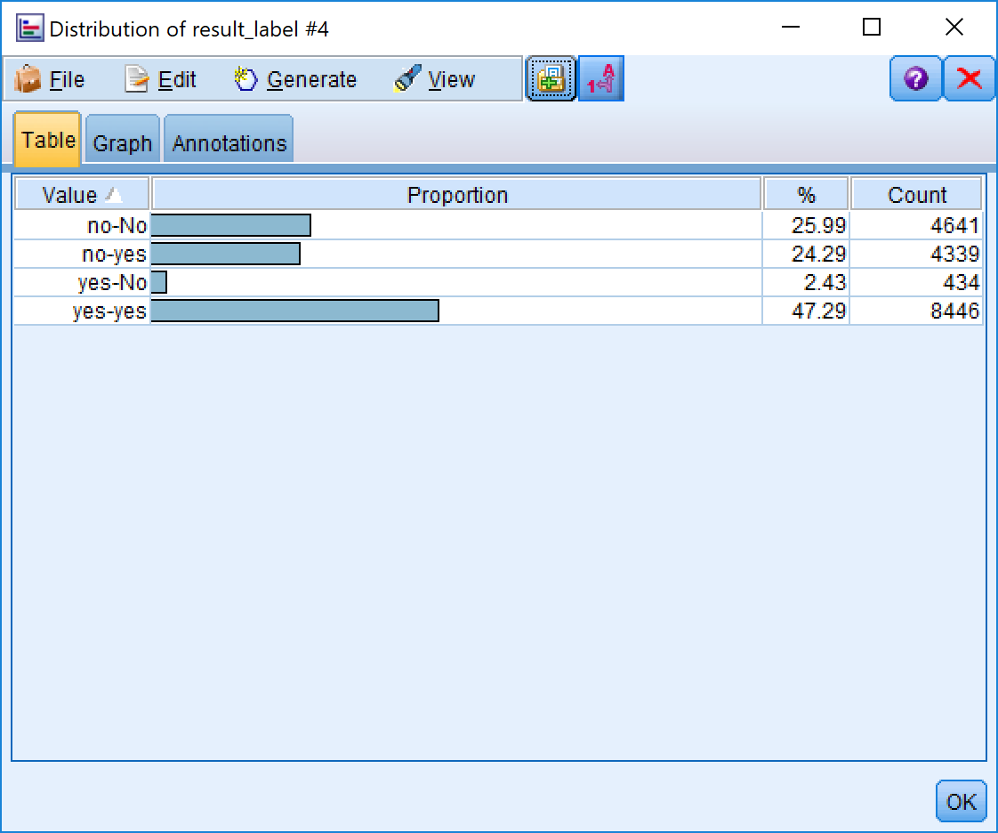

(Figure 16)

## 7.Data Mining

“Seventh is data mining: searching for patterns of interest in a particular representational form or a set of such representations, including classification rules or trees, regression, and clustering. The user can significantly aid the data-mining method by correctly performing the preceding steps.” (Fayyad et al., 1996) This is, of course, the flashy part of data mining, where sophisticated analysis methods are used to extract information from the data.

As we can see from Figure 17, we get a very good result from putting the whole datasets into this data mining models. Data from 45% of the total is marked as no-no, indicating that the original data is No, and all five models are calculated as No. For this part of the customers, we do not need to make a phone call and then from the total of 0.59% of the data. Being marked as “YES-No” indicates that if we call out according to this forecast data, we will lose 0.59% of potential orders. In conclusion, we reduced our out-of-pocket workload by 46.46%, lost 0.59% accuracy, and increased the effective rate of exhalation from 12% to 26.32%, which is consistent with and greatly exceeds our default target, so there is no doubt this project was successful.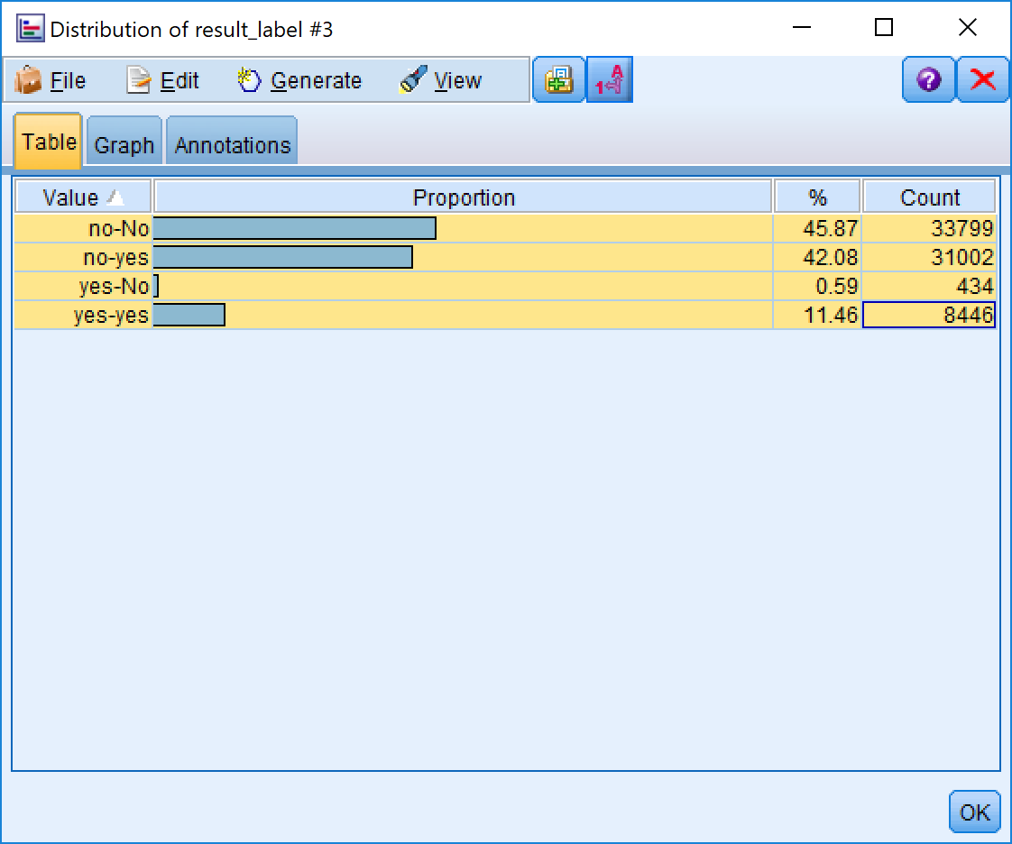

(Figure 17)

## 8.Interpretation

“Eighth is interpreting mined patterns, possibly returning to any of steps 1 through 7 for further iteration. This step can also involve visualization of the extracted patterns and models or visualization of the data given the extracted models.” (Fayyad et al., 1996) We assess and evaluate the models and the results and their reliability. “You are ready to evaluate how the data mining results can help you to achieve your objectives.” (SPSS, 2007)

From the whole project, there are four critical factors to predicate whether a customer would receipt marketing activity from phoning. They are Age, Job, Previous and Poutcome. We did not use the social and economic context attributes to prediction which included employment variation rate, consumer price index ,consumer confidence index, euribor 3 month rate and number of employees. It is not true we think they are not important. In conversely, we think they are very important factor for a bank marketing activity. It just because there are no these data in the dataset one (bank-full.cvs). In the future, we will consider how to use social and economic context attributes to extend our model.